**14.Design PDA using simulator to accept the input string anb2n**

**AIM:** To design PDA using a simulator to accept the input string anb2n.

**TRANSITION DIAGRAM:**

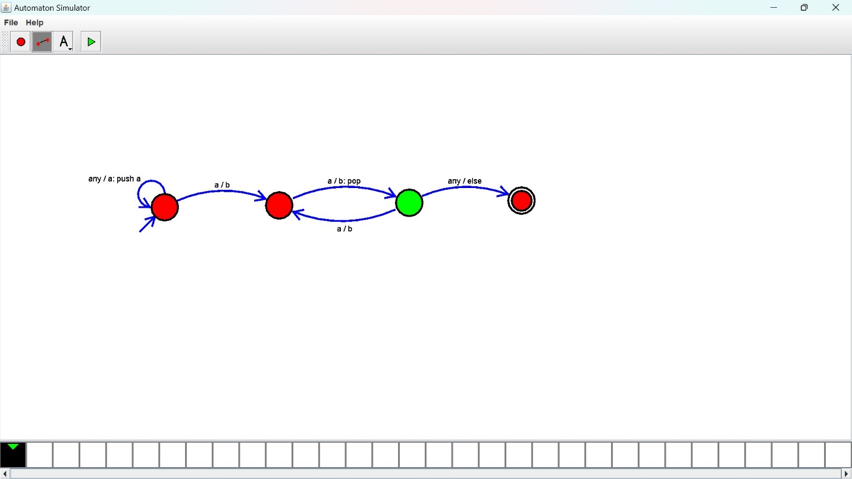

**RESULT:** The PDA is designed to compute the string given as input using a simulator.